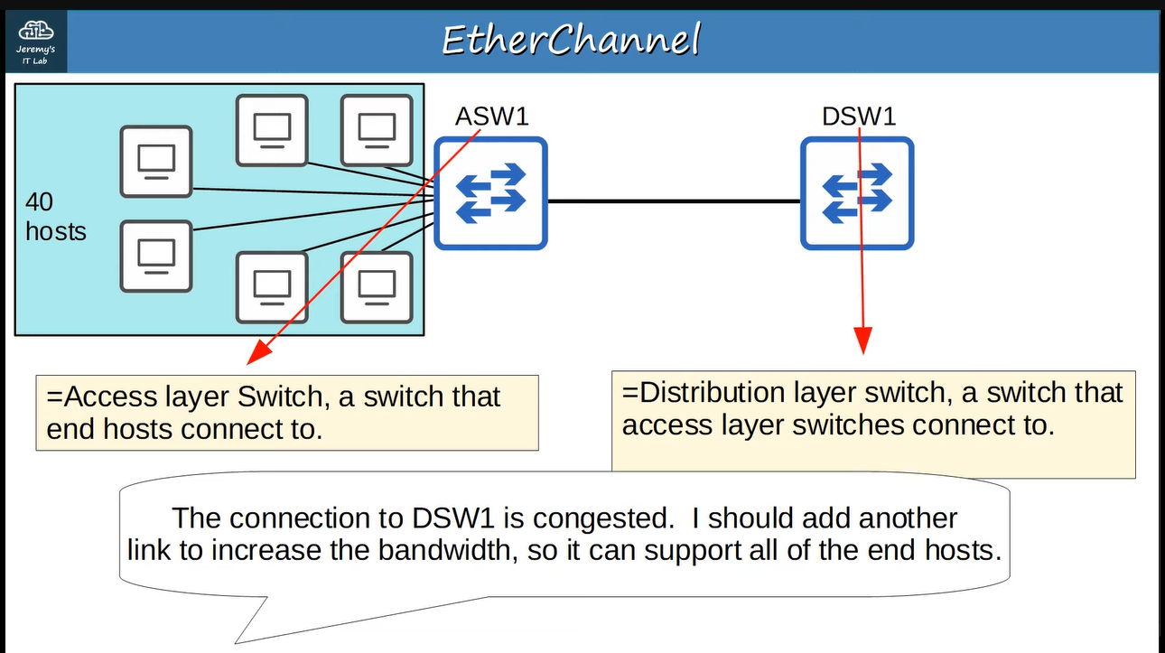 ↓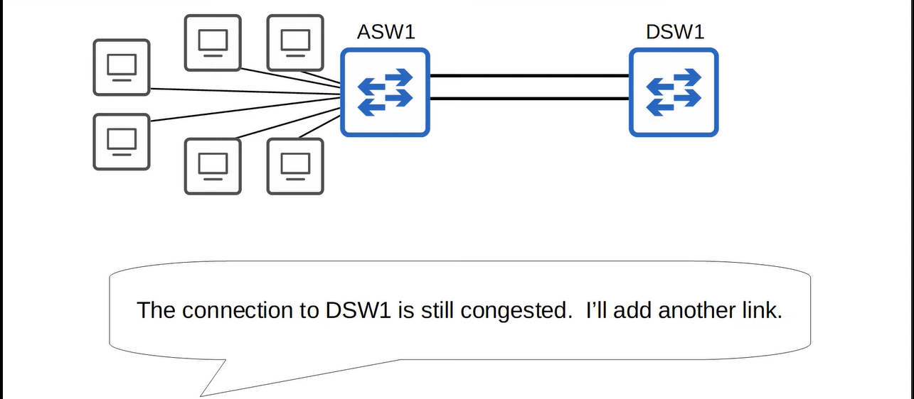 ↓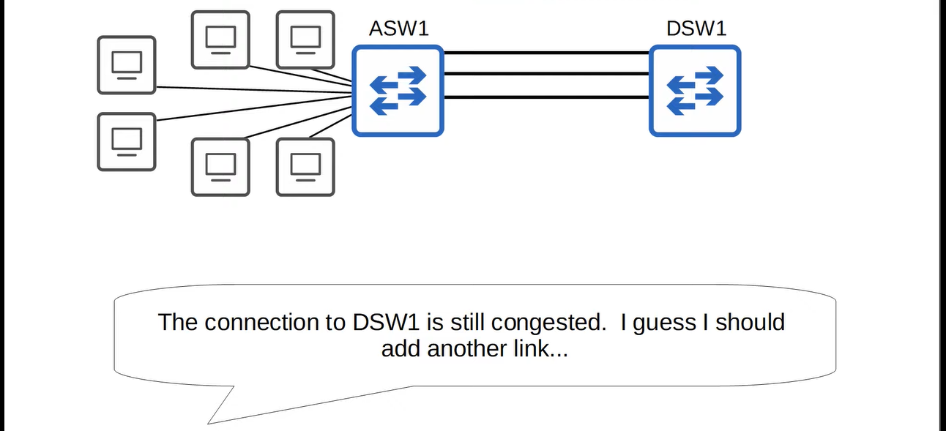

↓ 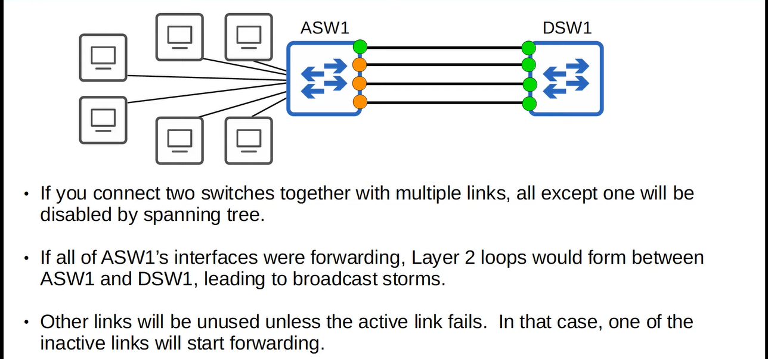**Here “ehterchannel” comes to solve this problem ↓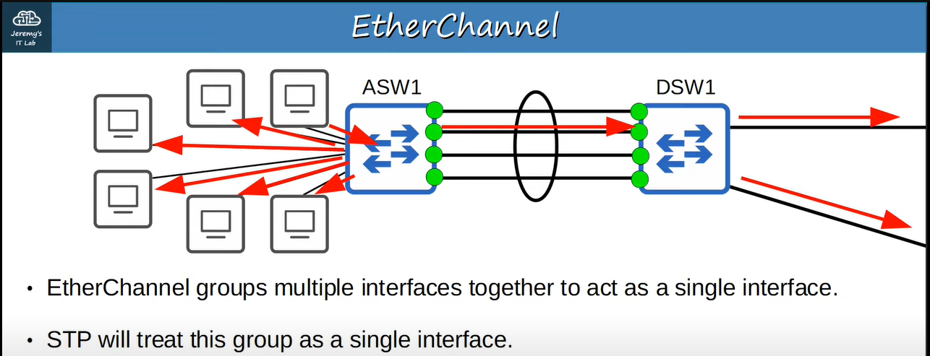It is like this ↓**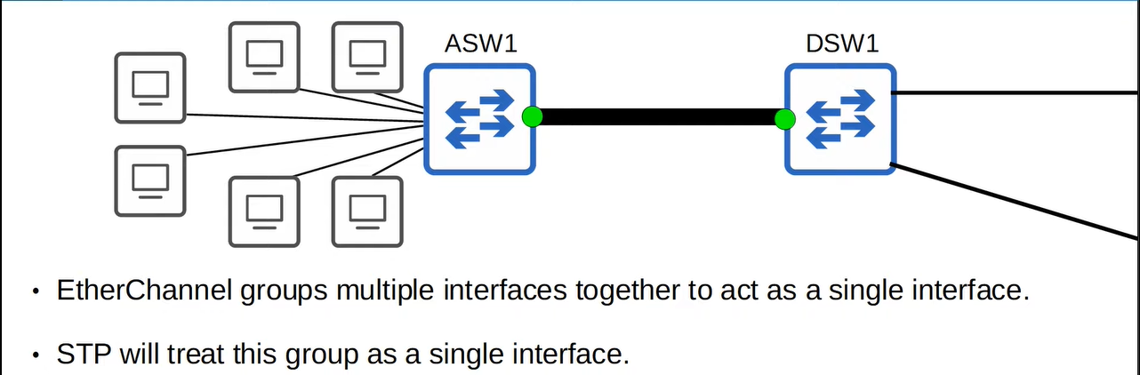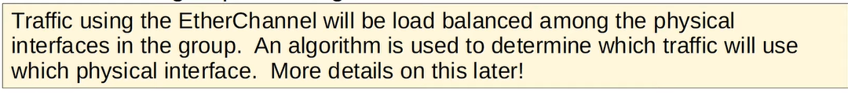

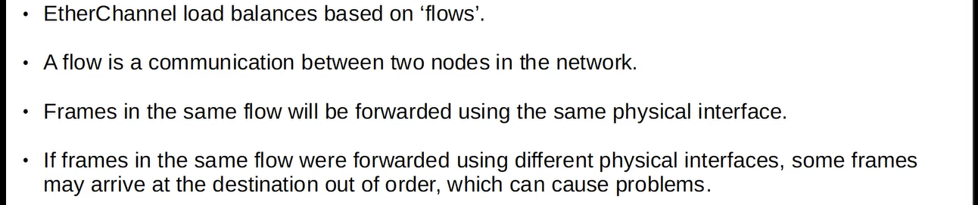**For example, sending first time ↓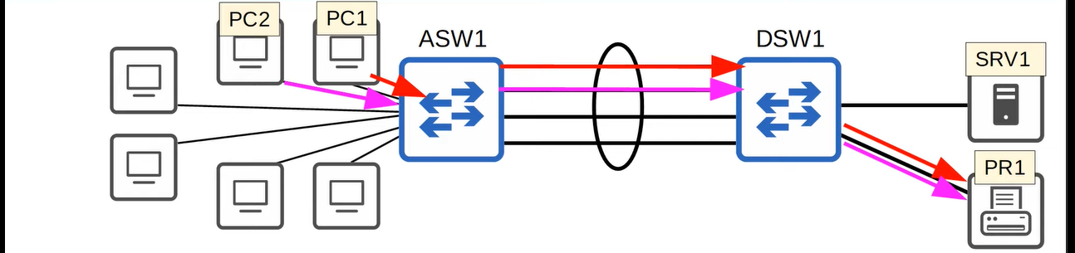sending second time ↓**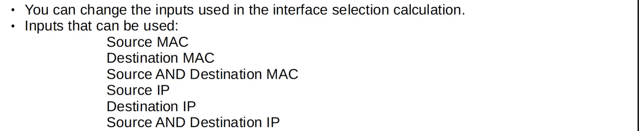

**Configuration of etherchannel load balancing ↓**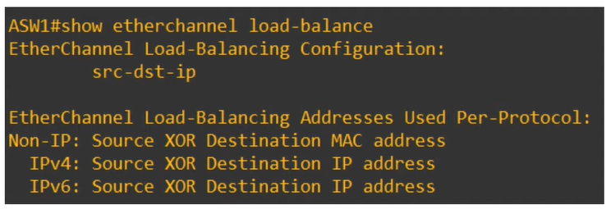

**↓**

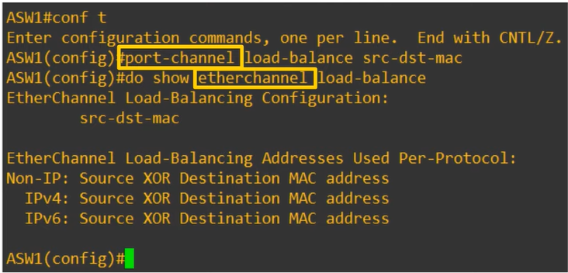

**Now we will see etherchanel configuration ↓**

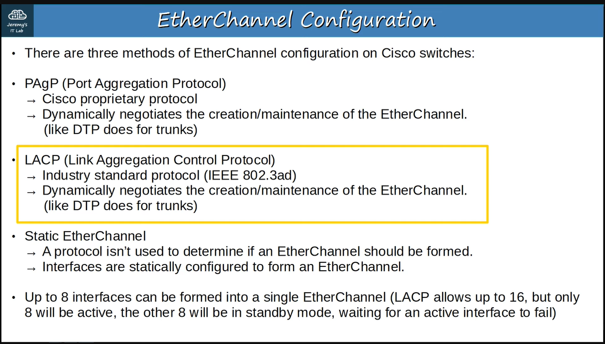

**Now we will see configurstionl of each method ↓**

**Remember ↓**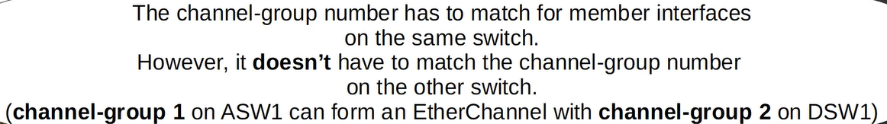

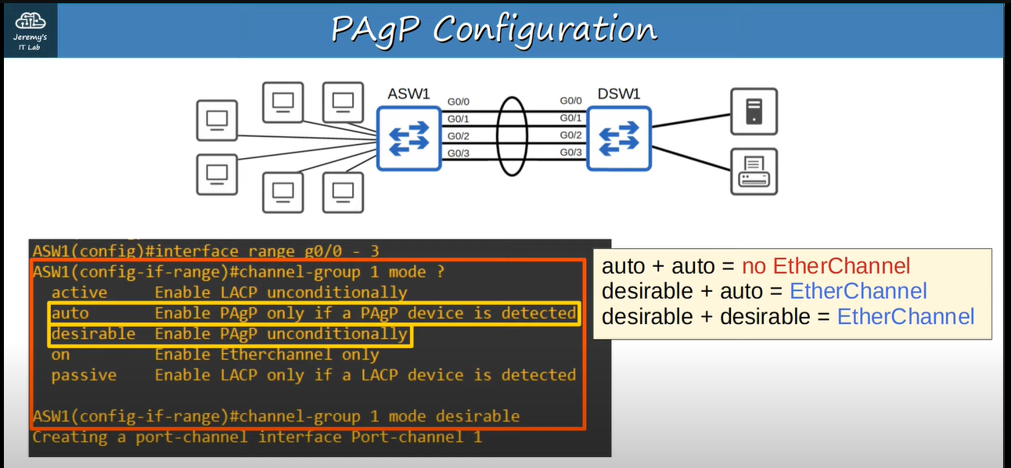

**you can see it ↓**

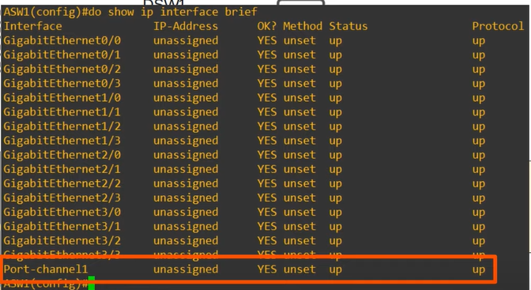

**So, the command is ↓**

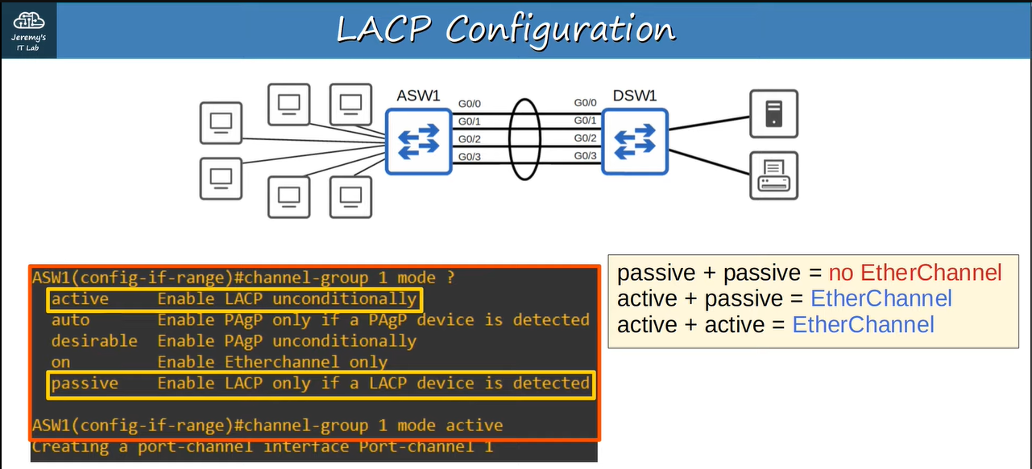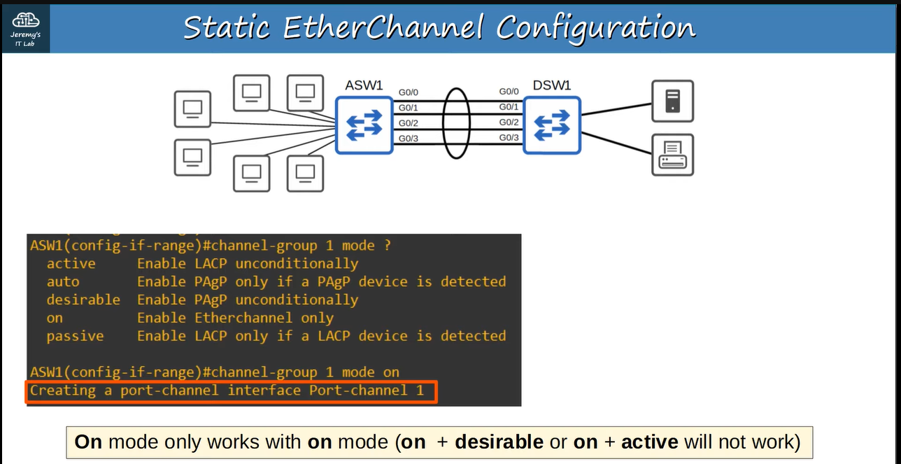**Another command that manually configures the etherchannel ↓**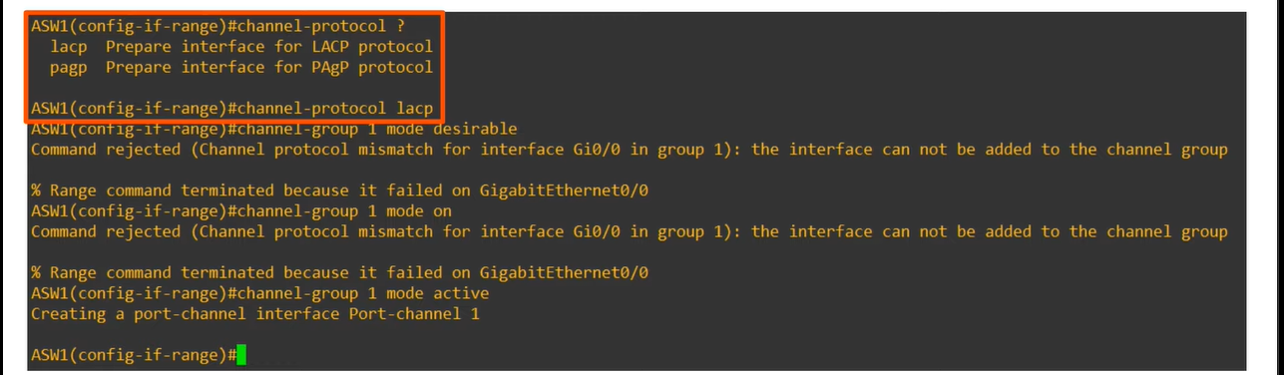

**We can then configure the port channel itself ↓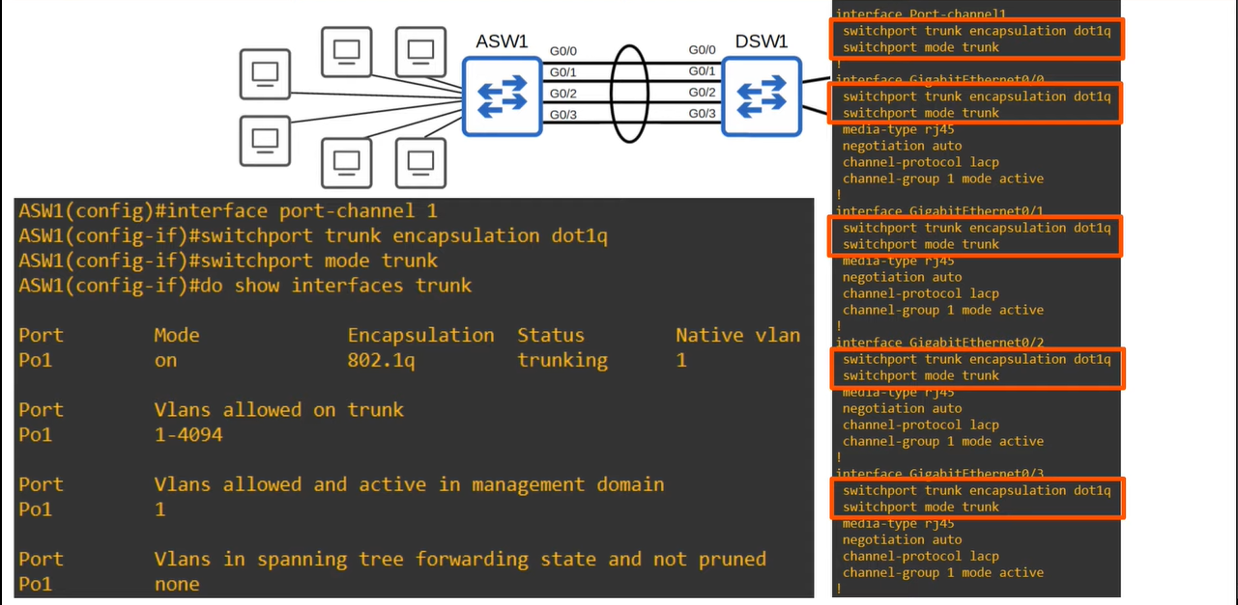Some important points about etherchannel configuration ↓**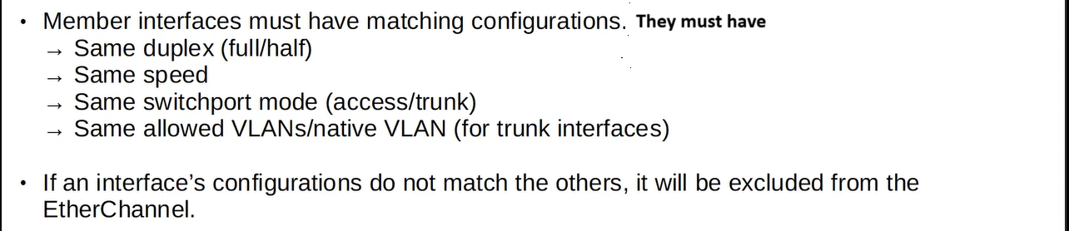

**Ethrchannl verification:**

**1) show etherchannel summary ↓**

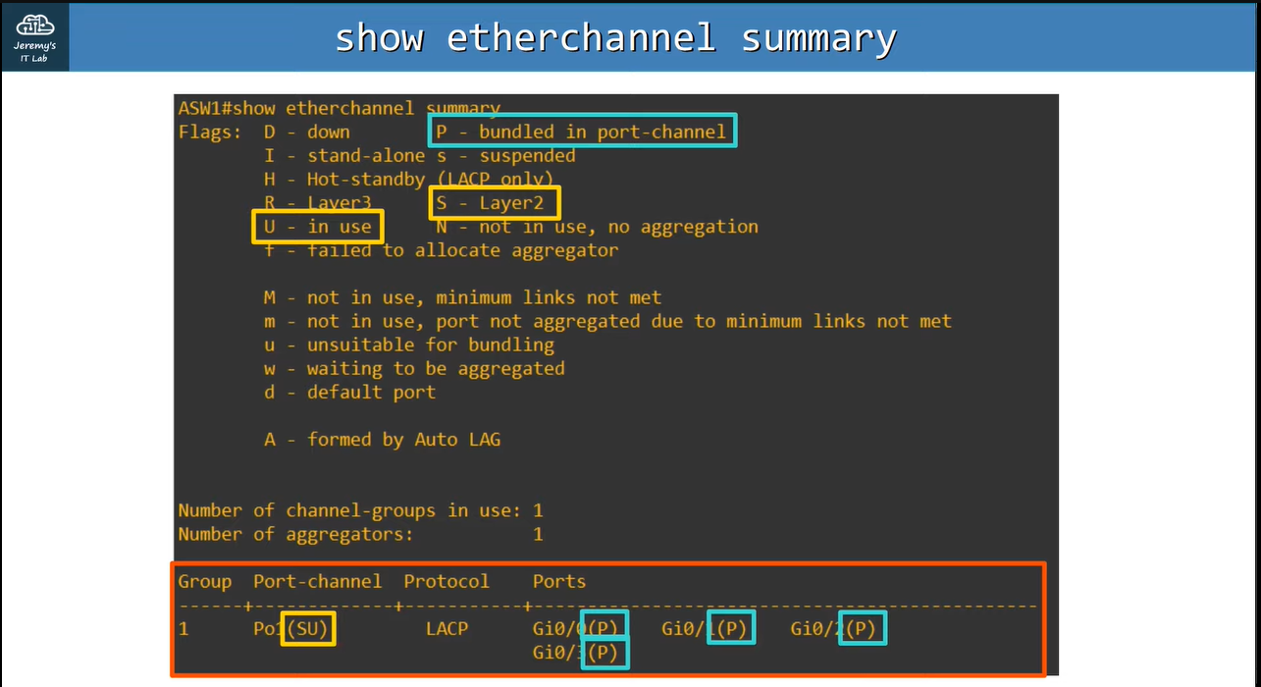

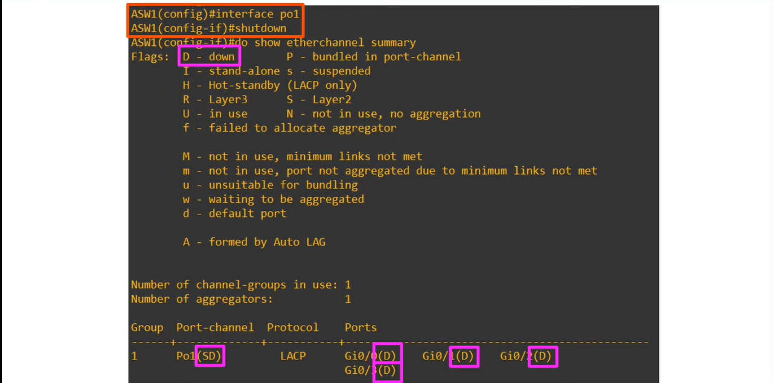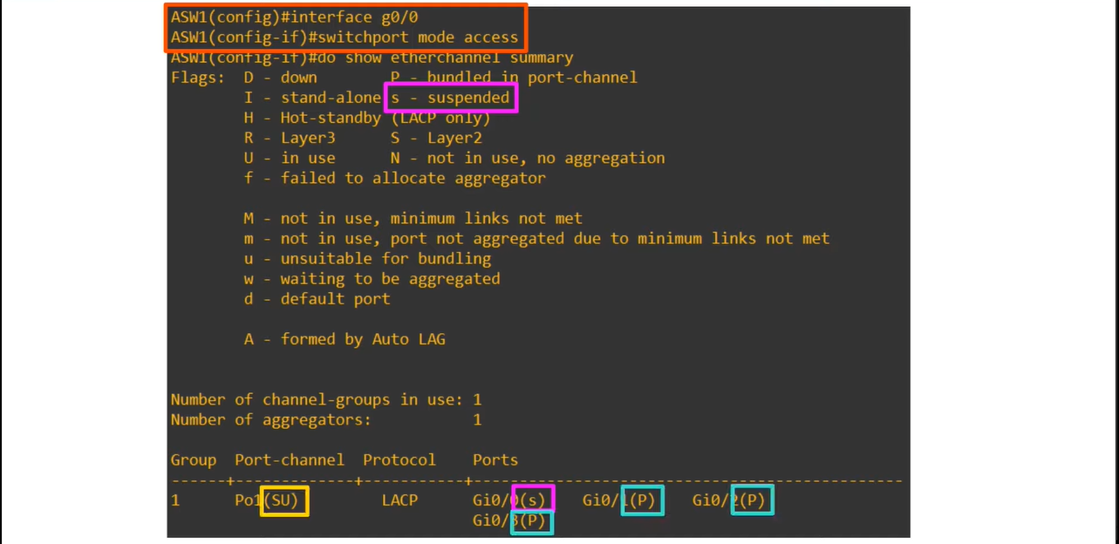**2) show etherchannel port-channel ↓**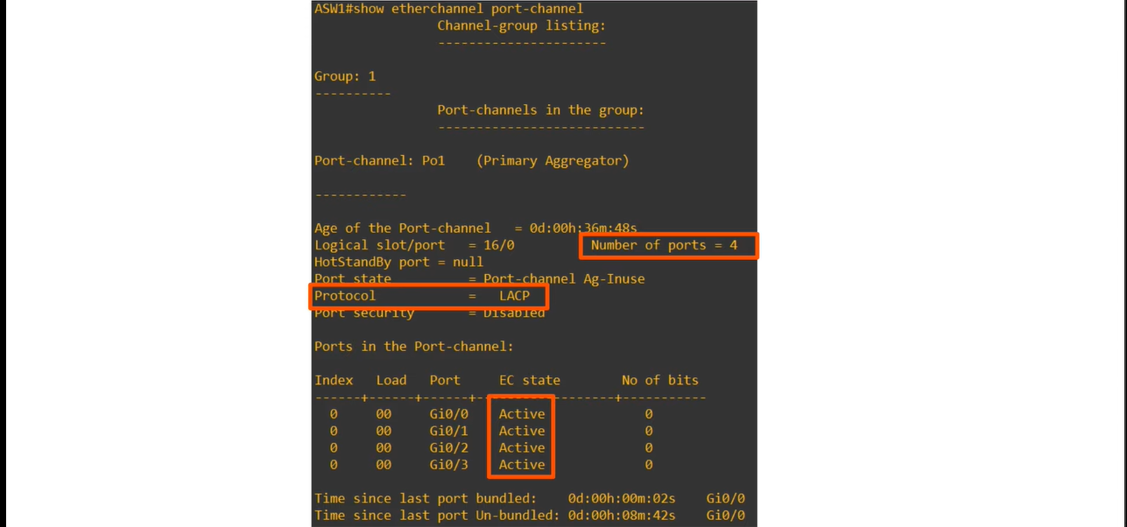

**STP(Spannig Tree Protocol) trearts these four physical interfaces as a single logical interface ↓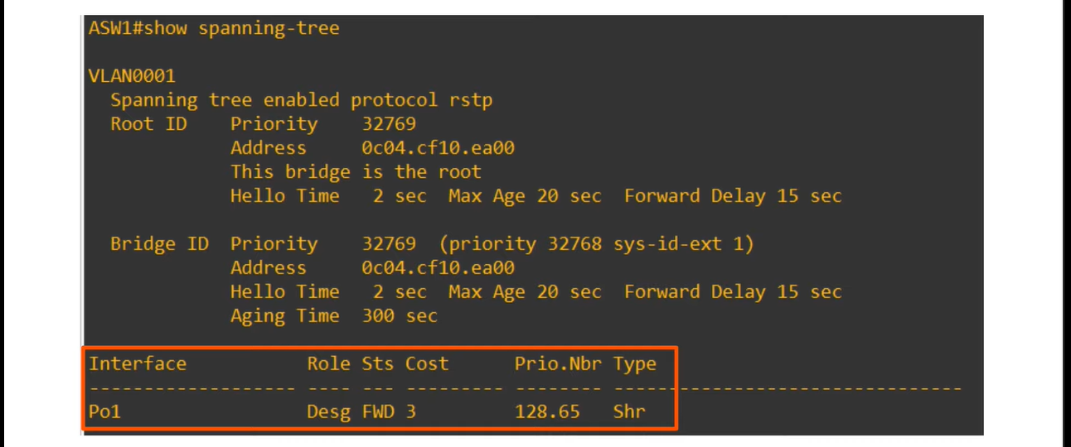If there are more than two loops are connected with eachother then the broadcast storm will be created, e.g., ↓to stop it, STP will block any port ↓**

**Now we will see etherchannel on layer-3 switch ↓**